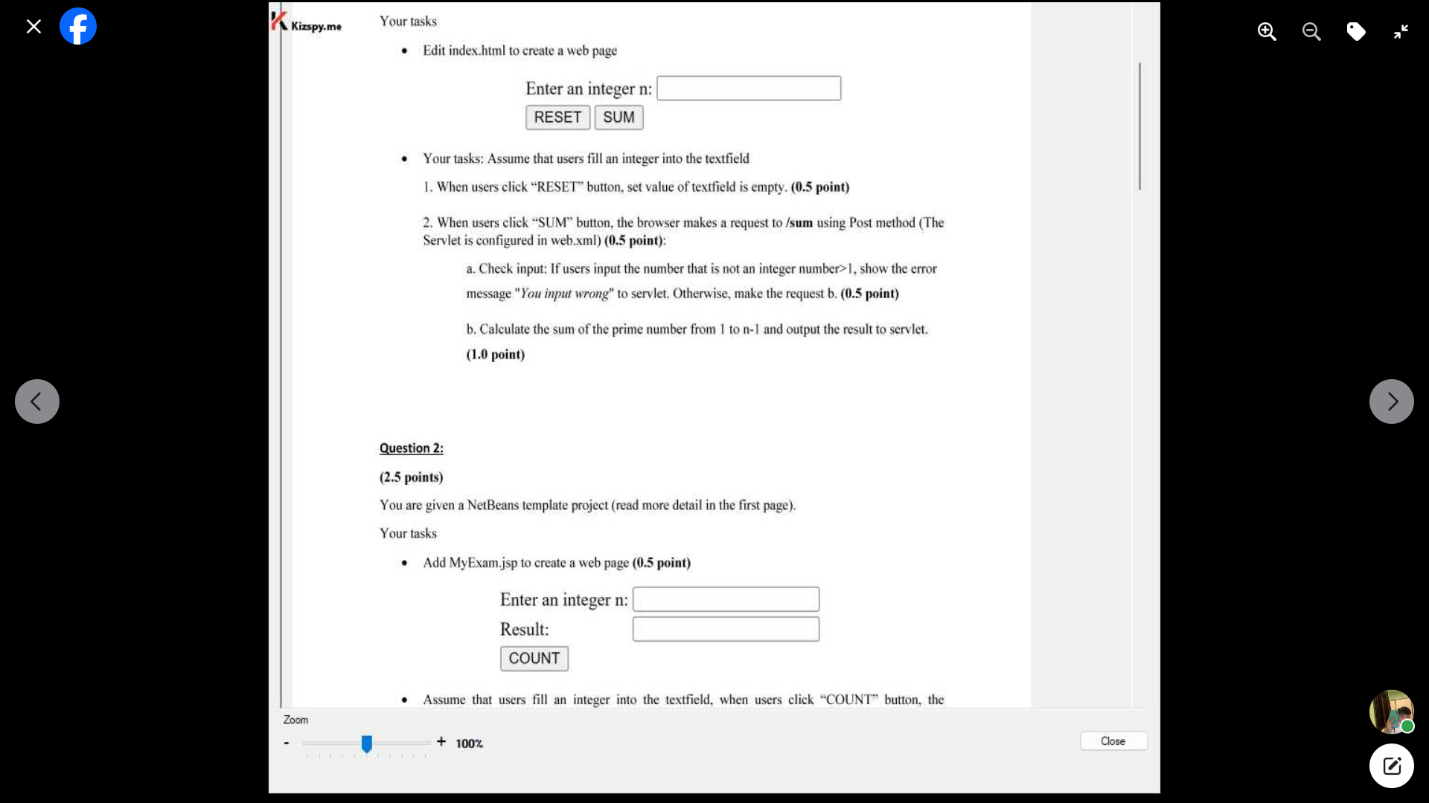

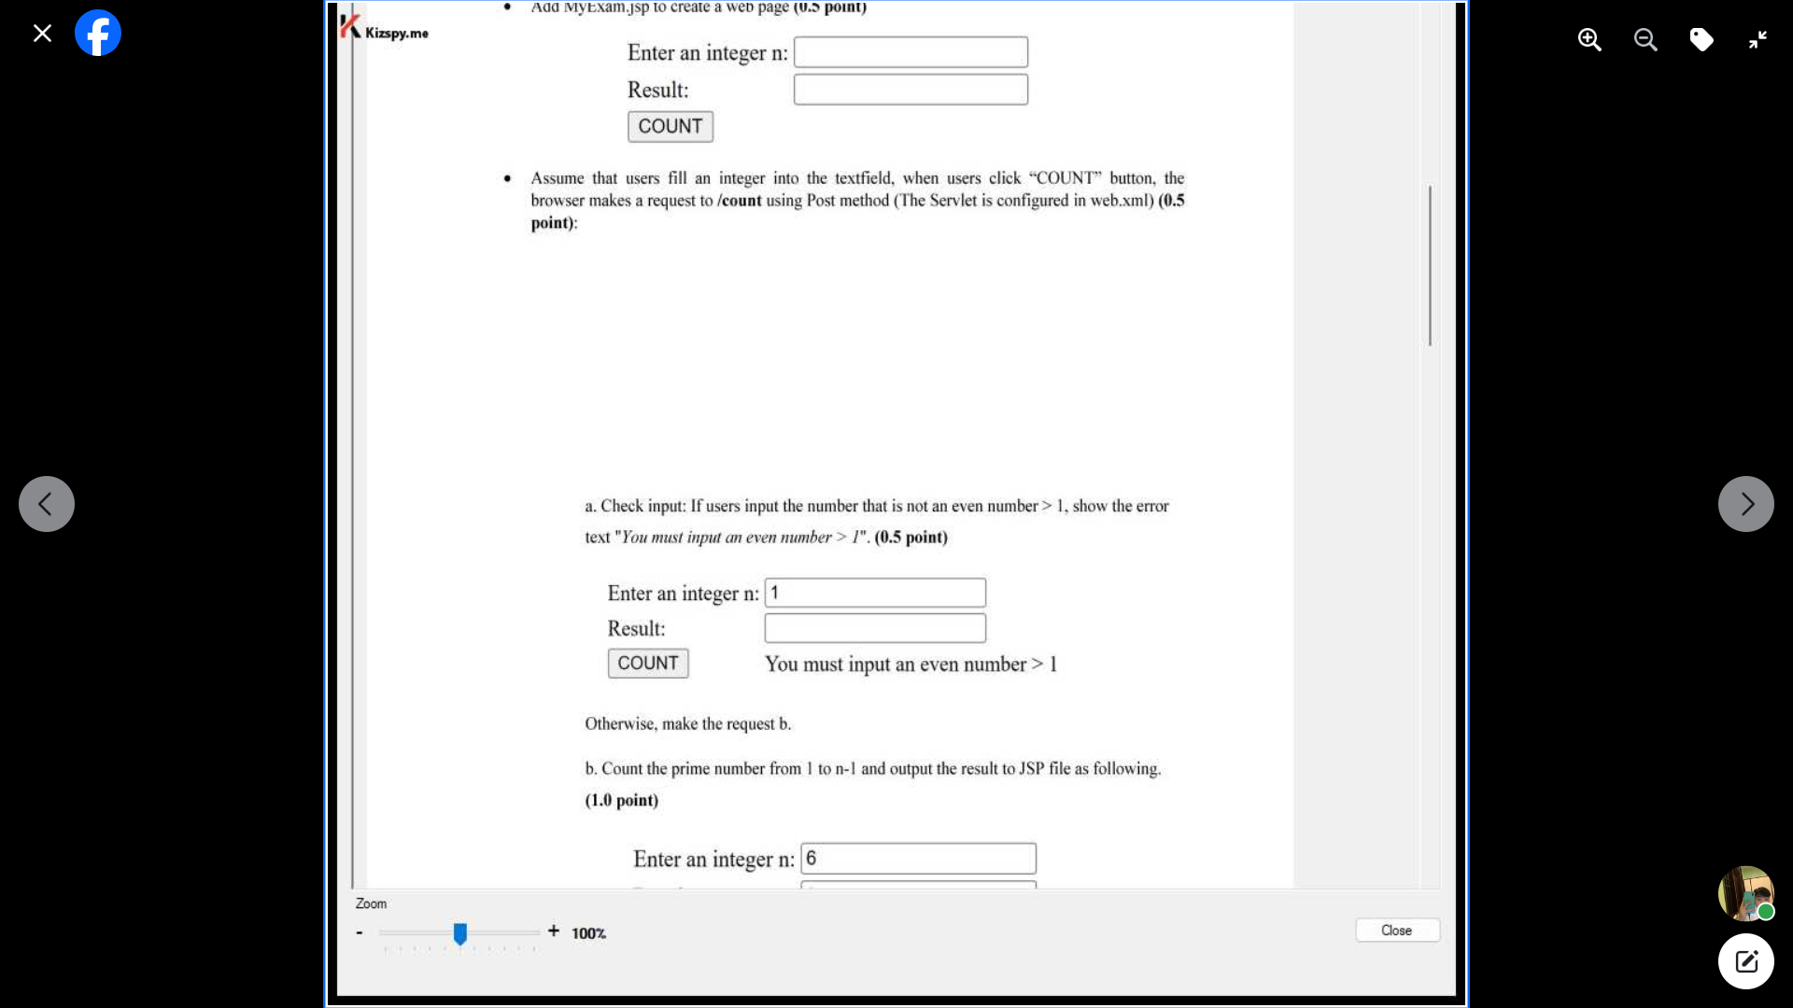

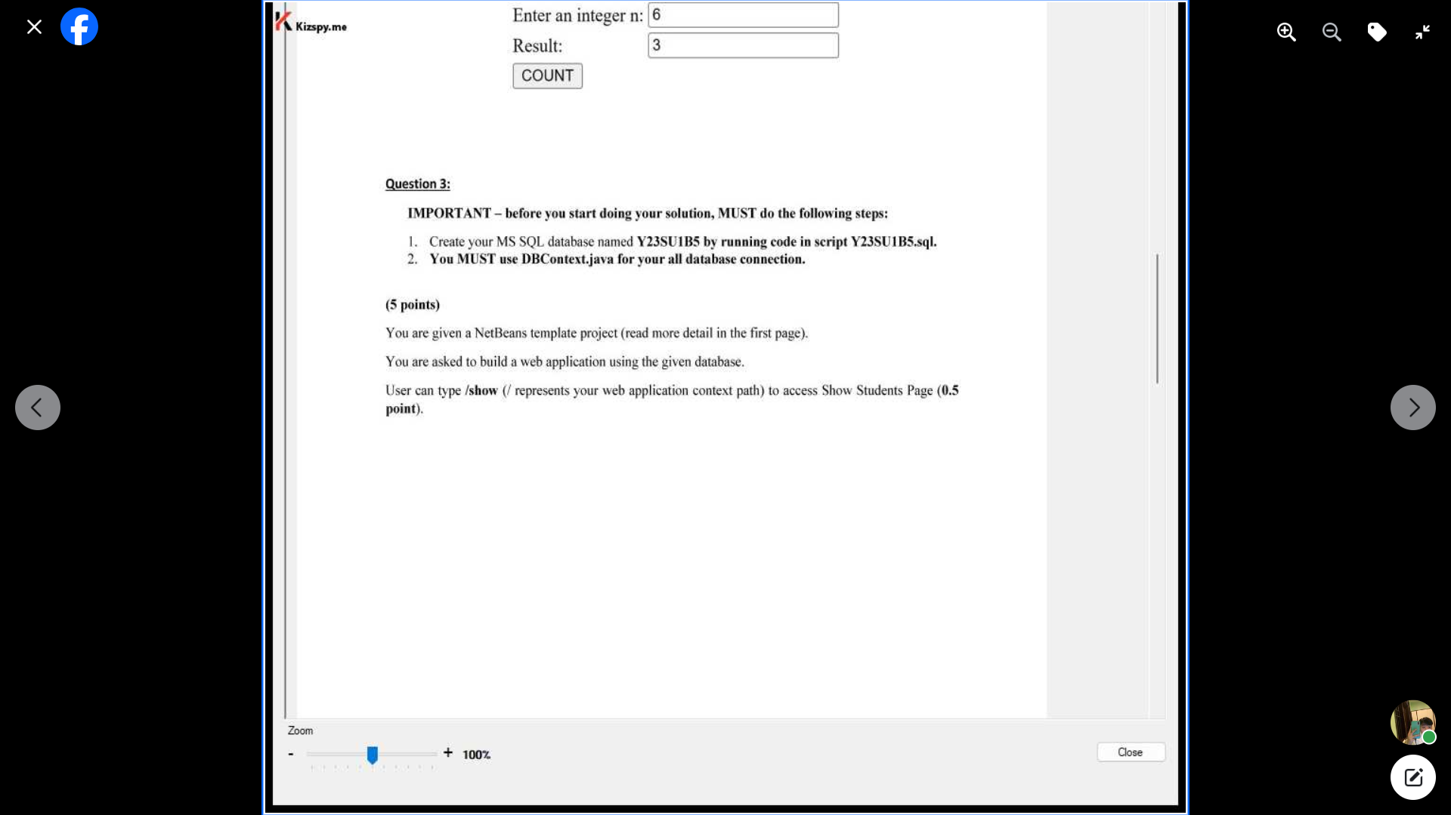

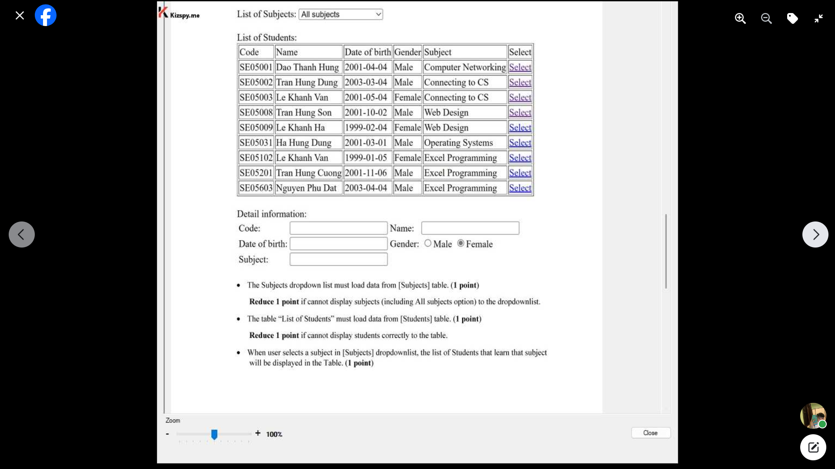

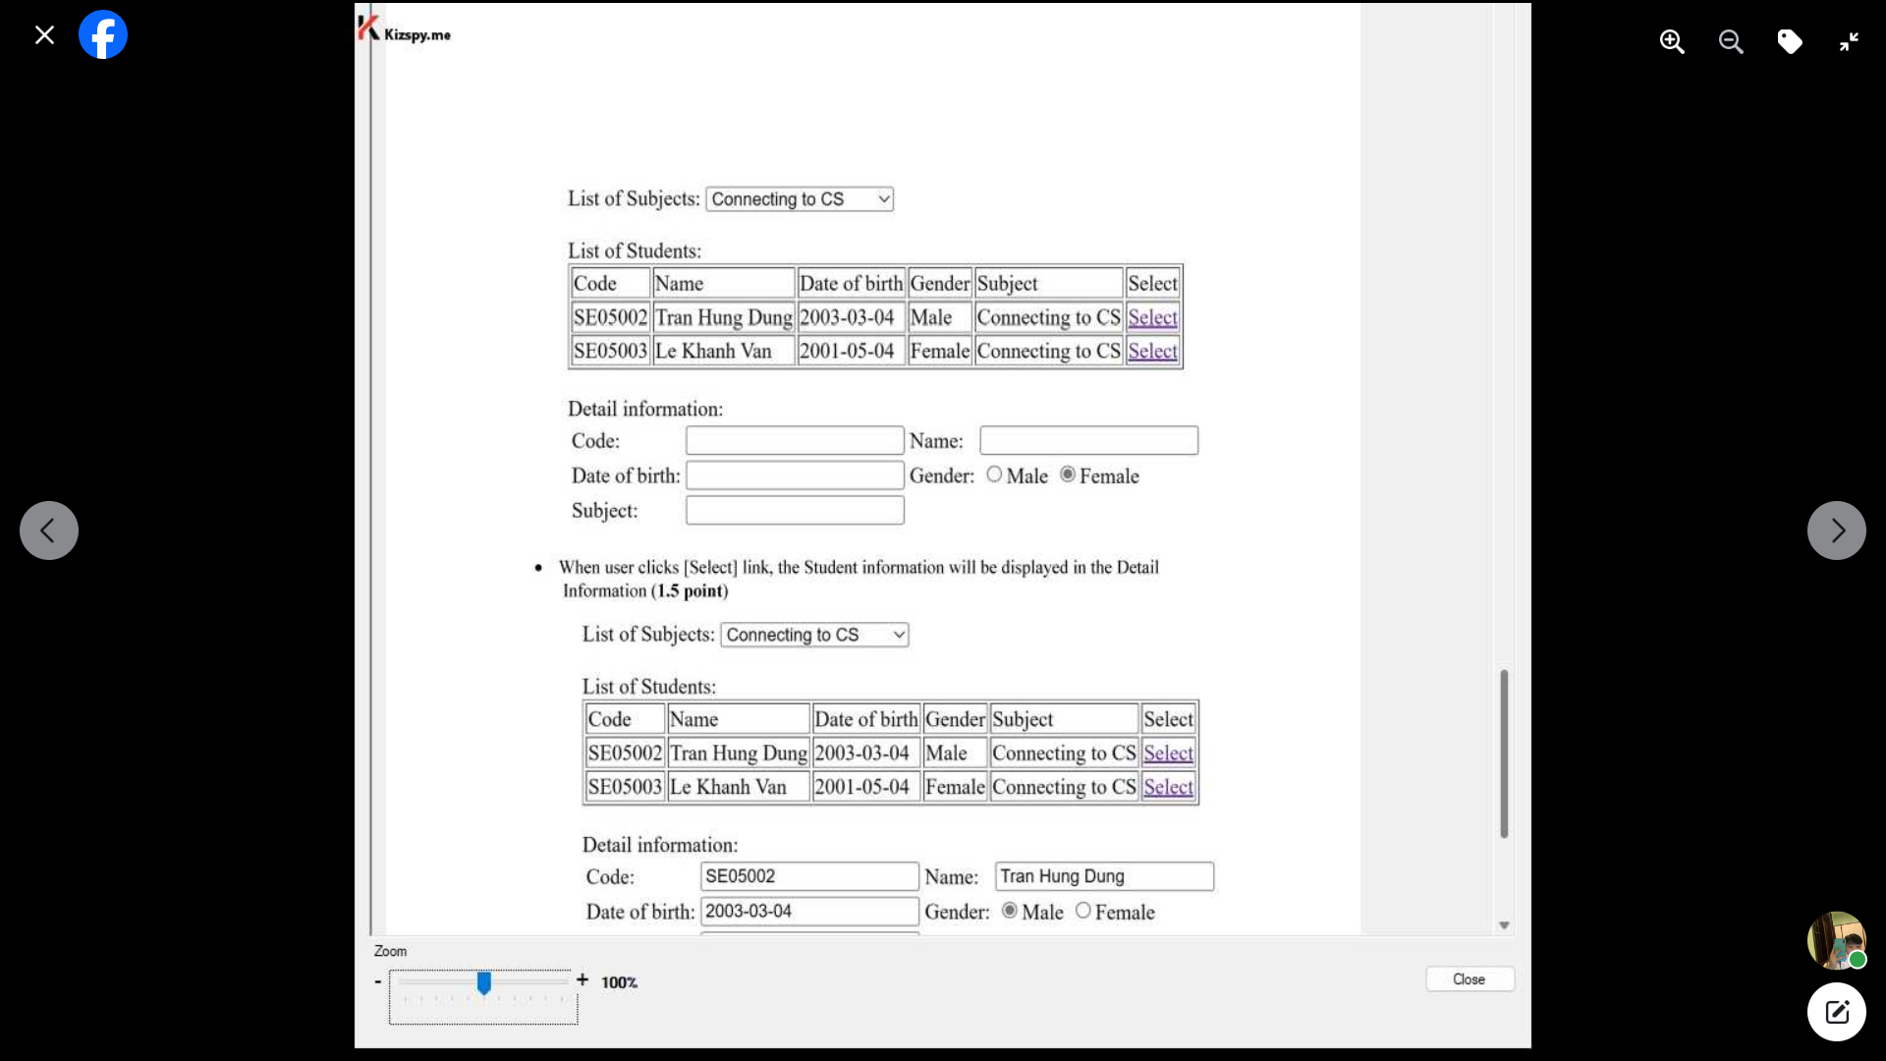

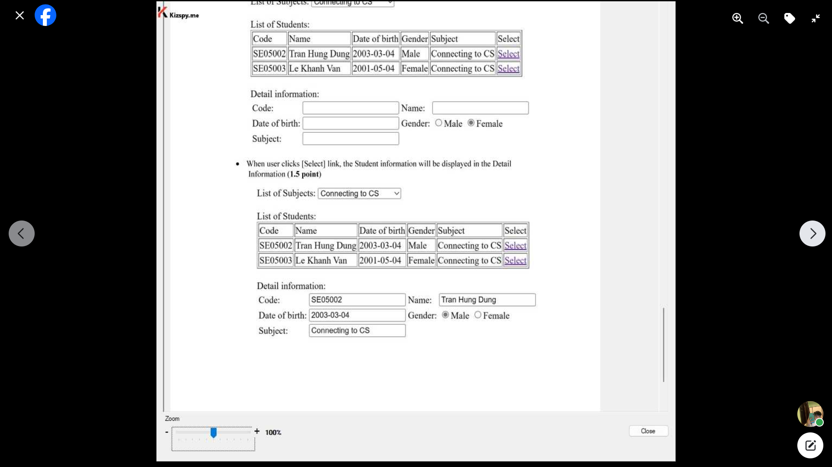

Link DB:

https://drive.google.com/file/d/1xl_jUtHqC28rFFJaZFhWwiwhbGwLpZrk/view?fbclid=IwAR2y8jpv19e-XHKM-0s3I9W5w5LZWSckkexR2ufQHKkkVqlp2SQP-MnXnA4